Output Of this Code Of Implement Of Spring Security With Authentication

1.When we run the code

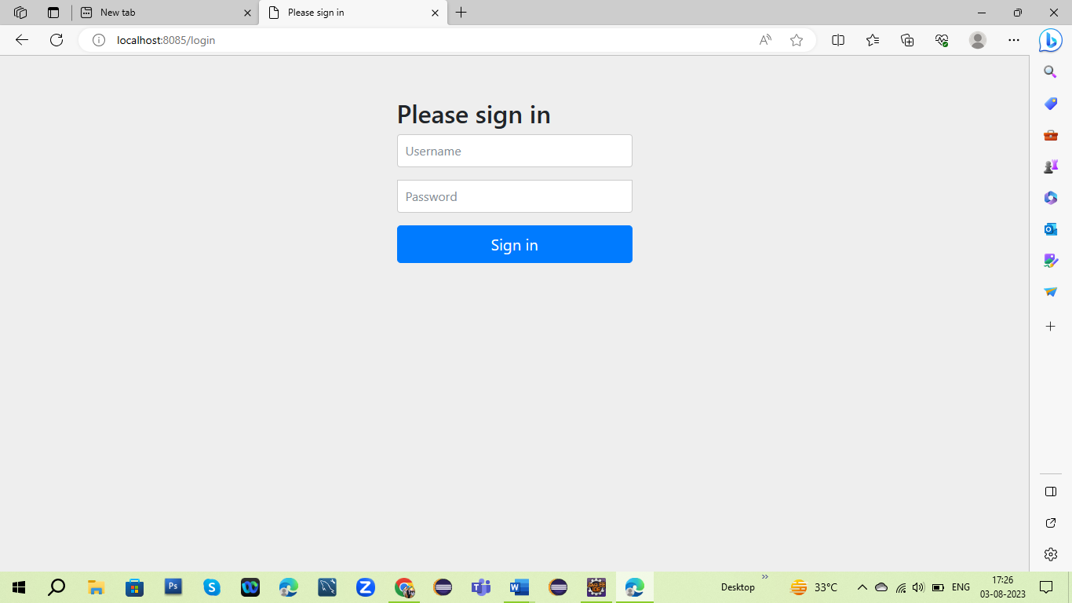

2.When we put all the details of username and password

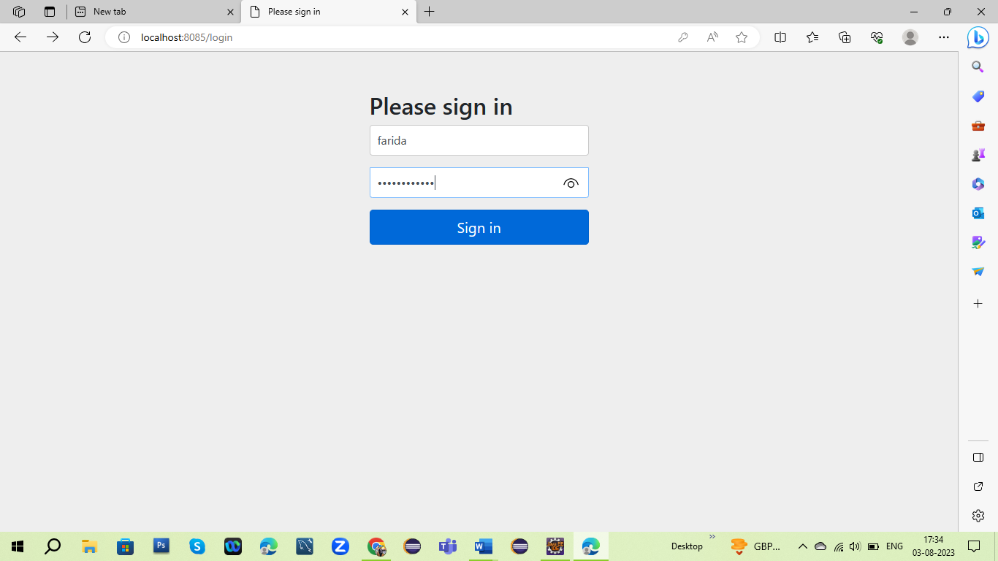

3.When we sign after putting the detail then I get some output in login page

